**Week 7 Writeup**

# RECAP: Week 6 Summary

1. **[MON]** – update congestion algorithm, clustering in Blenheim map (for different congestion levels)
   1. Use the vector/scalar context files for the clustering
   2. Test against the data in the files
   3. Try using date started & date finished – use pandas function between
2. **[TUE] –** generalise between edges (2 methods)
   1. **Crps_between_edges.py:** fit distribution on one edge, test against data from another edge
   2. **Mergefit.py:** fit distribution on N datapoints from each edge
      1. **Try it out randomly**
      2. **Use edges with only a little data for comparison.**
      3. **Try using a proportion from all edges e.g. 0.5**
   3. Look online: are there issues with CRPS. Does the CRPS favour the mean?
   4. Does the min change?
   5. Use CVM / KS
   6. How to interpret scale of CVM
3. **[WED]** – Fixed parameterisation discrepancies between Scipy and my implementation. Implement **mergefit_crps_ks.py** with plots/CRPS/KS values
4. **[THU]** – Linear regression for lognormal parameters vs edge length
   1. Offset is clearly linear
   2. Mean could be linear. Var could be polynomial. Probably influenced by other factors
   3. To do: try multivariate regression
5. **[FRI]** – Fix **mergefit_crps_ks.py**
   1. KS is a better metric due to intuition:
      1. Original fit is better than mergefit according to KS. Vice versa for CRPS
      2. KS is bounded between 0 & 1 so it is clear what constitutes a “good” KS score
   2. Around 5 datapoints is the best n_samples
   3. Draw AAF, TSC, LABS maps – AAF or TSC might be most appropriate. I might choose AAF for the simpler names + it’s clear that some edges “should” be in the same cluster

# PLANS: Week 7

1. **[MON]** - Fix issues from last week (check congestion algorithm against scalar context, randomise datapoints for mergefit, answer questions about CRPS/KS/CVM, fix my implementation of CVM test)
2. **[TUE]** - Fit distributions for STRANDS datasets. Is lognormal still a good fit?
3. **[WED]** - Cluster edges according to KS, CVM, edge length, connections, max angle of turning etc.
4. **[THU]** - Classification based on factors (edge length, connections, etc). Output is binary: do 2 edges belong to the same cluster?
   1. Input = factors, Output = Similarity measure for a regression
   2. Input = factors, Output = Binary classification for whether 2 edges are similar
      1. Build a ground truth using KS/CVM
5. **[FRI]** - Test classification on the other map against a "ground truth" determined by KS/CVM clustering

**[OTHER]** – Plot parameters vs factors. Any correlations? Any other factors

**[OTHER]** – Multivariate regression for parameters vs factors – cautious

* 1. output = lognormal params
  2. input = factors that affect clustering

# Fix Issues from Wk6

#### Congestion

Used data from YAML files (processed with scalar contexts).

Function to get data: **get_data_yaml.py**

Execute clustering algorithms in **MAIN7.ipynb**

**Clustering by spatial feature:**

Cluster by edge length:

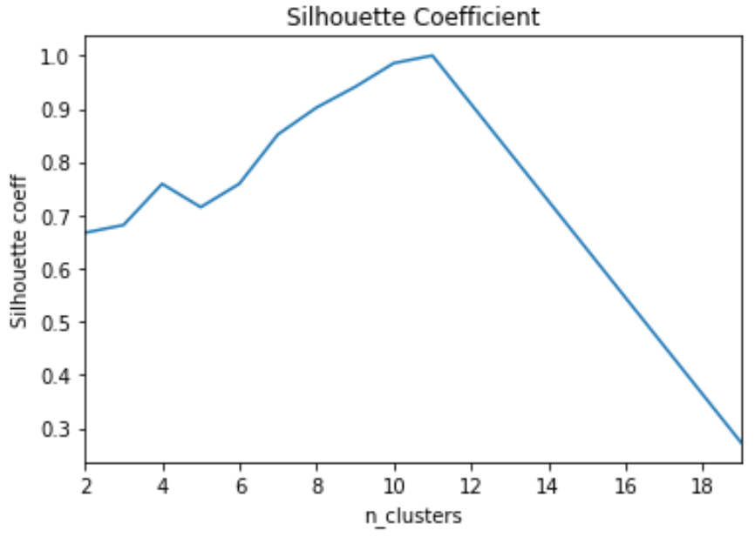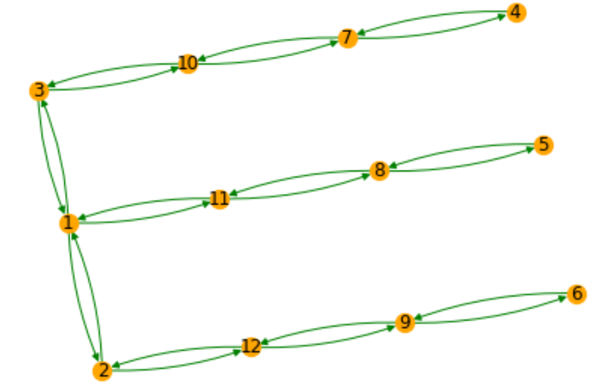

Cluster by connections:

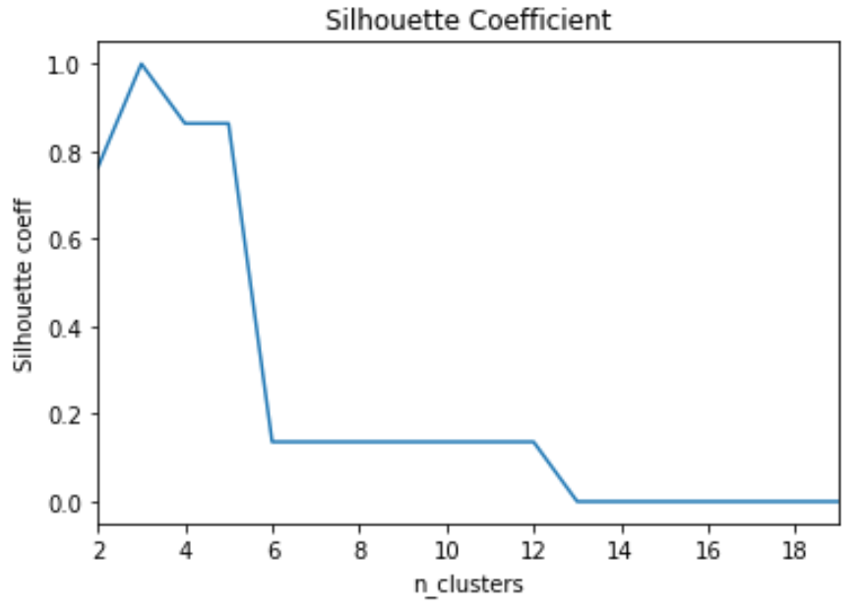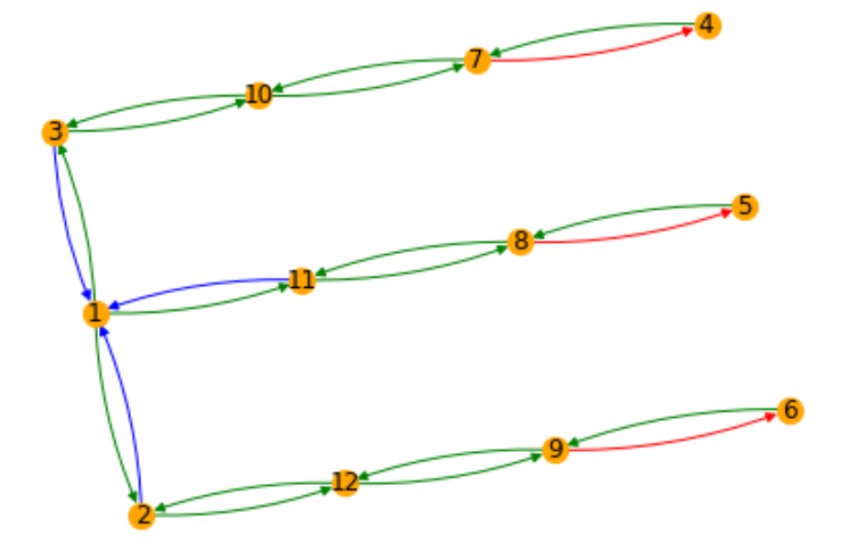

**Clustering by KS metric for different levels of congestion**

1 cluster for all levels of congestion

We have:

* 12995 datapoints for 1 robot
* 7818 datapoints for 2 robots
* 1924 datapoints for 3 robots
* 216 datapoints for 4 robots
* 9 datapoints for 5 robots

1 robot 2 robots 3 robots

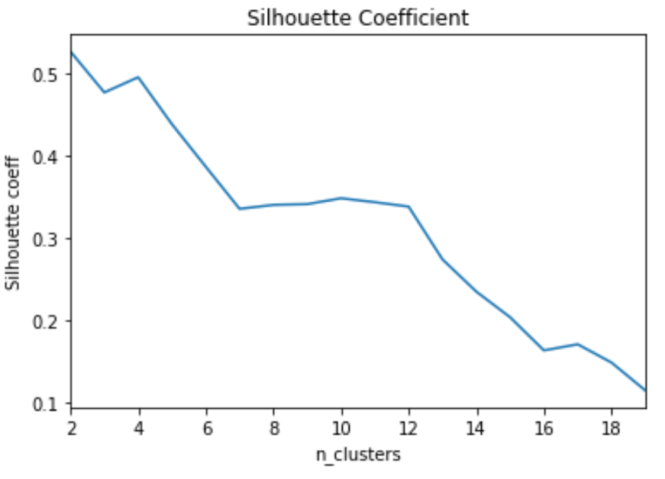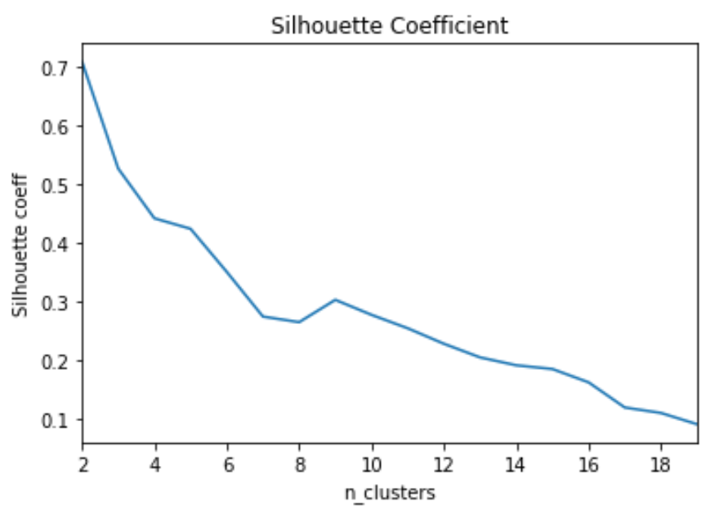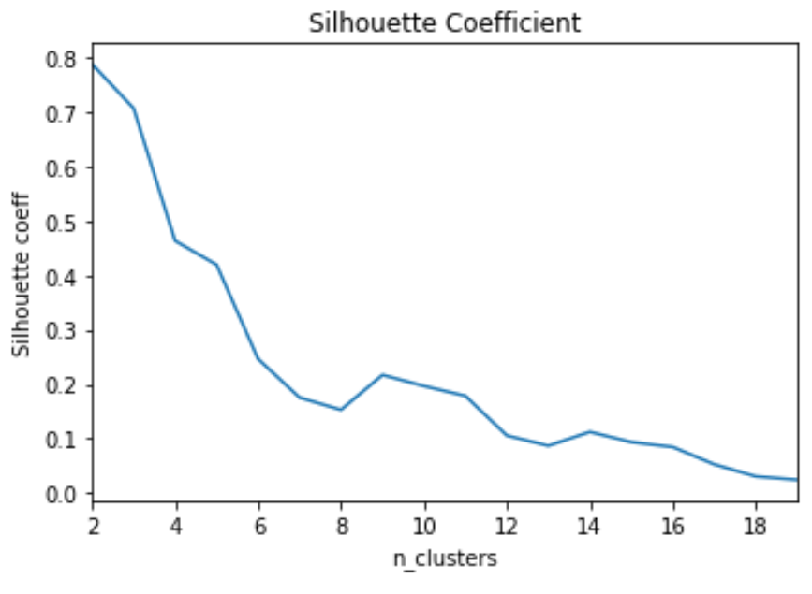

4 robots

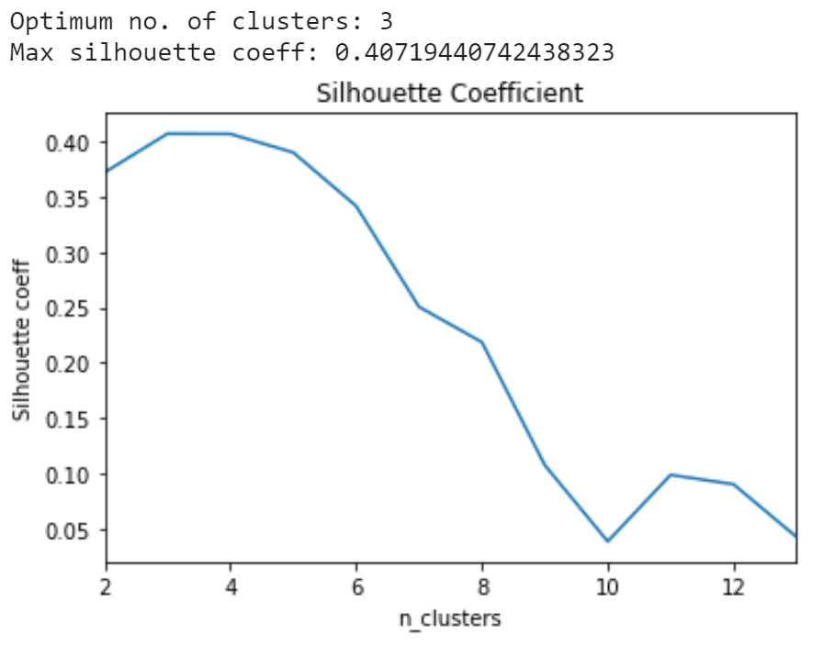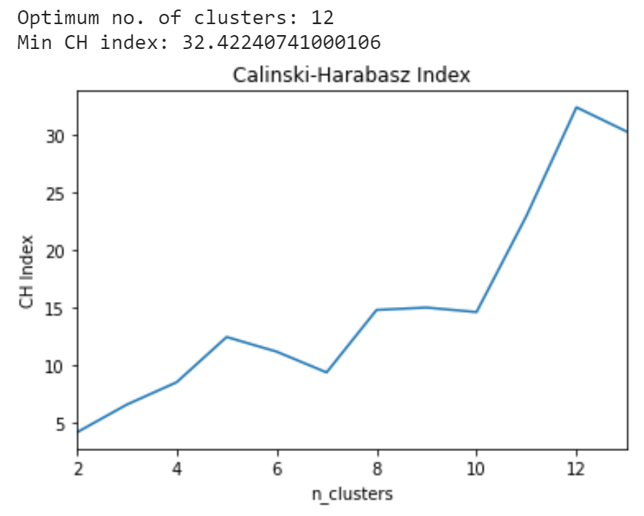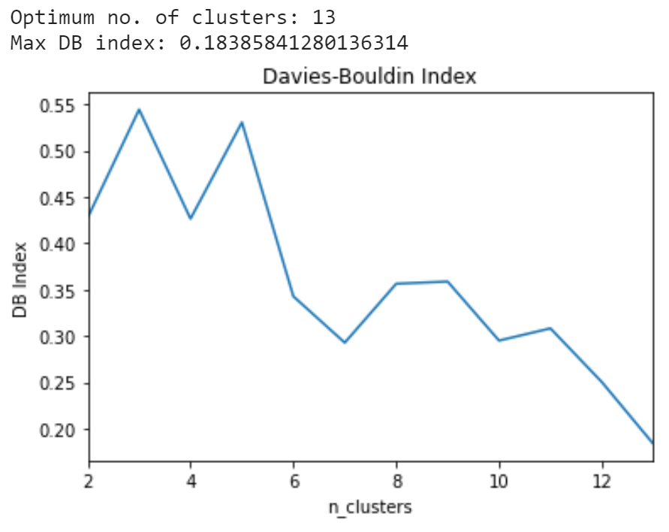

#### Randomise data for mergefit

Use pandas sample function:

**df = df.sample(frac = 1).reset_index(drop = True)**

There is little difference between successive randomisations (see **MAIN6.ipynb**), but this is a necessary step to allow for “generalisation” arguments.

#### Clarify CRPS / KS / CVM

CRPS is like one sample CVM. Taking median/mean is not an efficient use of available data.

* In practice, taking the mean favours smaller samples, since we are less likely to get extreme values.
* Taking the median artificially creates high CRPS scores since a score close to the peak is the lowest possible
* CRPS is very useful if the distribution is unknown or can not be easily specified. However, in our situation, we do know the distribution (lognormal) so CRPS provides no advantage over CVM

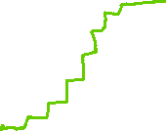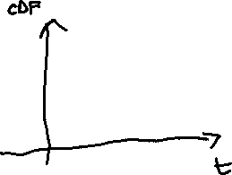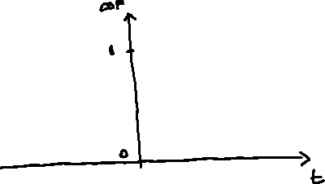

Red is single sample EDF for CRPS

Blue is CDF of predicted distribution

Integral of the square distances between curves is CRPS

TLDR: CRPS is not a great metric if you have lots of new observations

**Critical values for CVM (Baringhaus_CVM): i.e. we want CVM score less than 0.22**

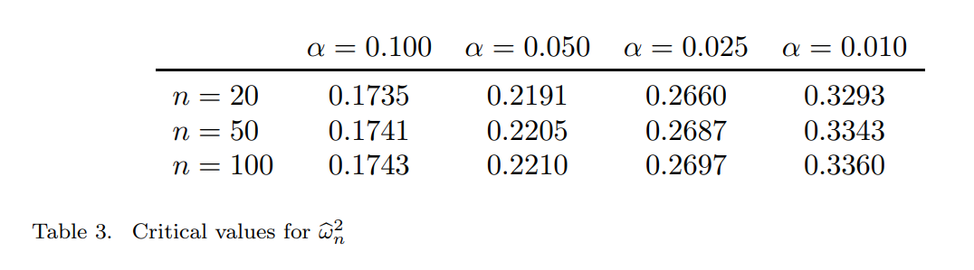

Critical values for 2-sample KS (**Massa_KS**):

**D_crit = c(alpha) / SQRT(n)**

Critical values for 2-sample KS (**PWessel2014_CriticalKS**):

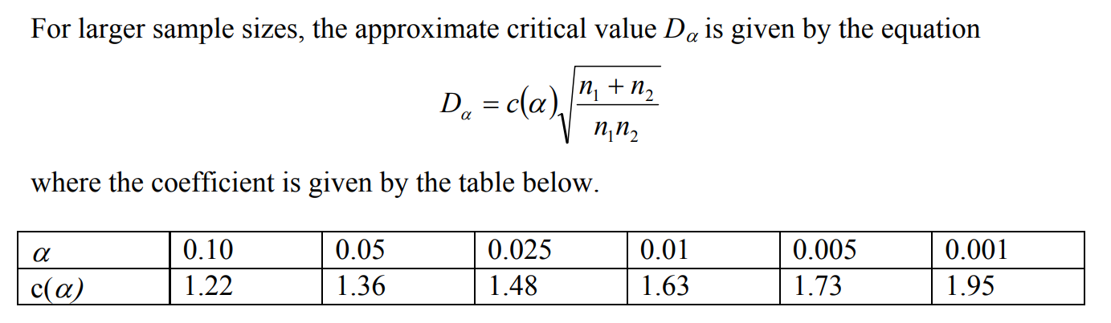

#### Fix implementation of congestion algorithm

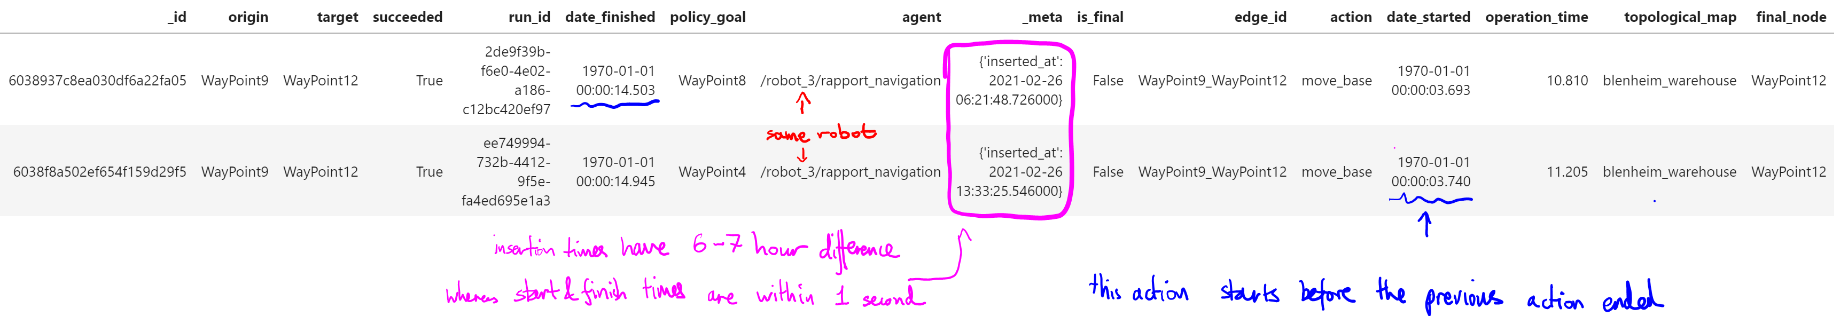

**Clarify what time to use:**

For the same robot:

1. Robot 3 has overlapping “date_started” & “date_finished” with a different run completed by Robot 3, suggesting that the robot timer may have been reset?
2. However, the “_meta.inserted_at” times are different, suggesting this is the actual time, which was not reset

This is not unique to these 2 datapoints. For Robot 3, it has many entries of “date_started” within 2 seconds:

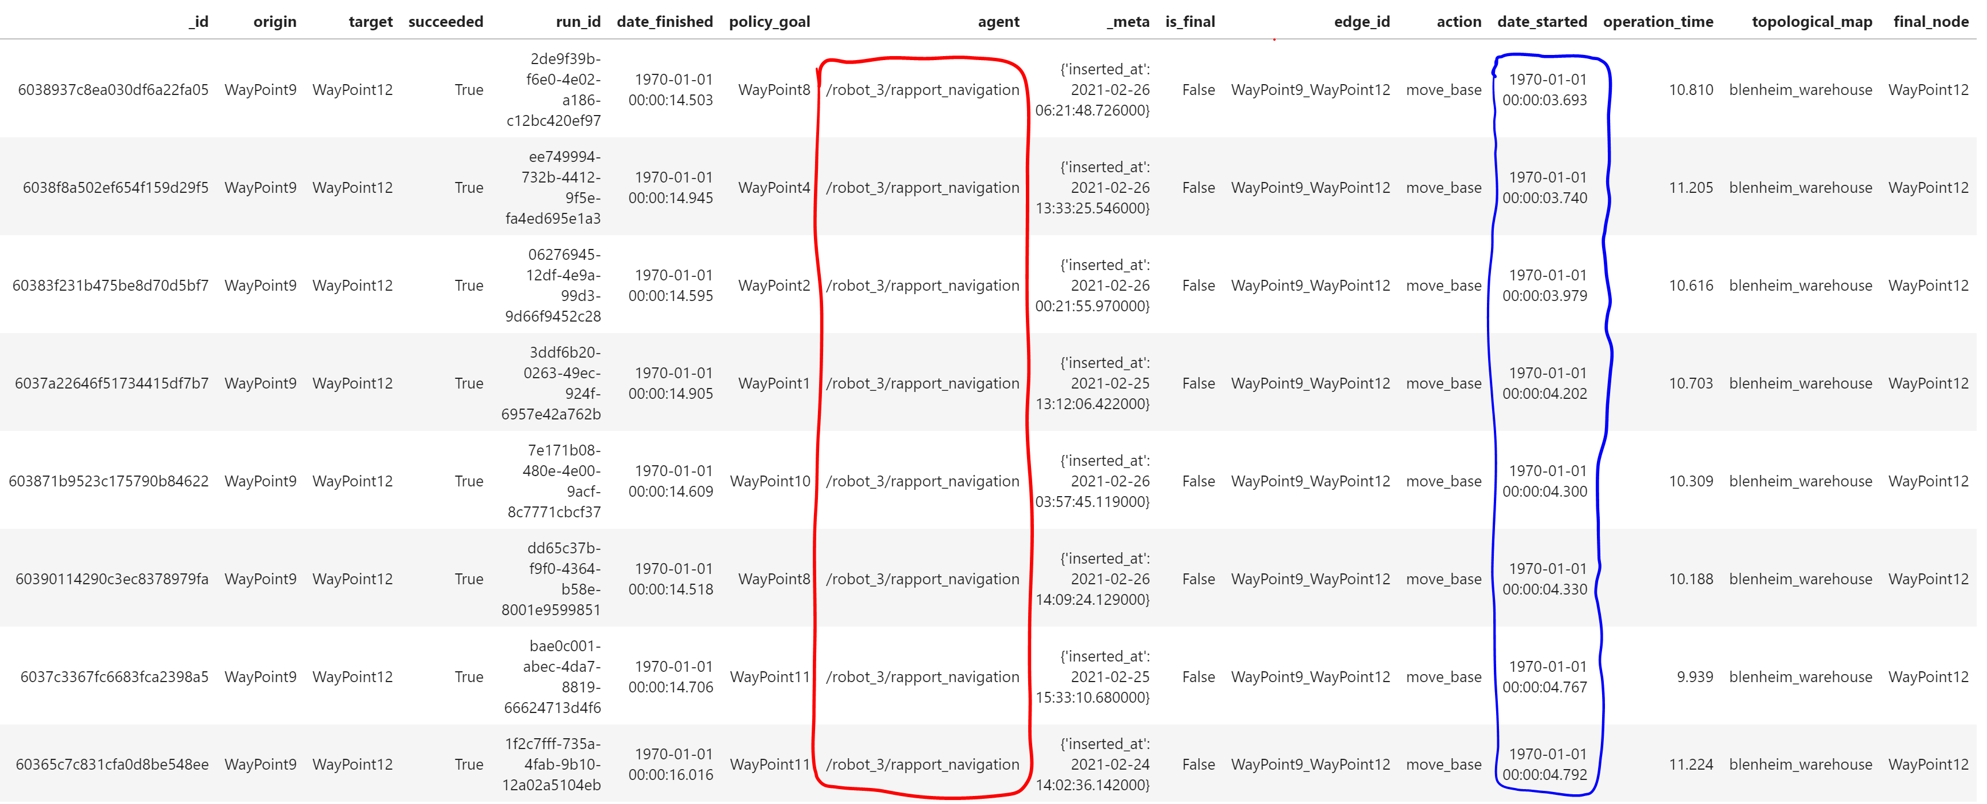

**Should we be using “_meta.inserted_at” as the time when we consider congestion?**

#### Fix implementation of CVM

Source for CVM implementation: [scipy/_hypotests.py at v1.7.1 · scipy/scipy (github.com)](https://github.com/scipy/scipy/blob/v1.7.1/scipy/stats/_hypotests.py#L266-L379)

My understanding of CVM was previously wrong: (see [Cramér–von Mises test - Oxford Reference](https://www.oxfordreference.com/view/10.1093/acref/9780199541454.001.0001/acref-9780199541454-e-1882))

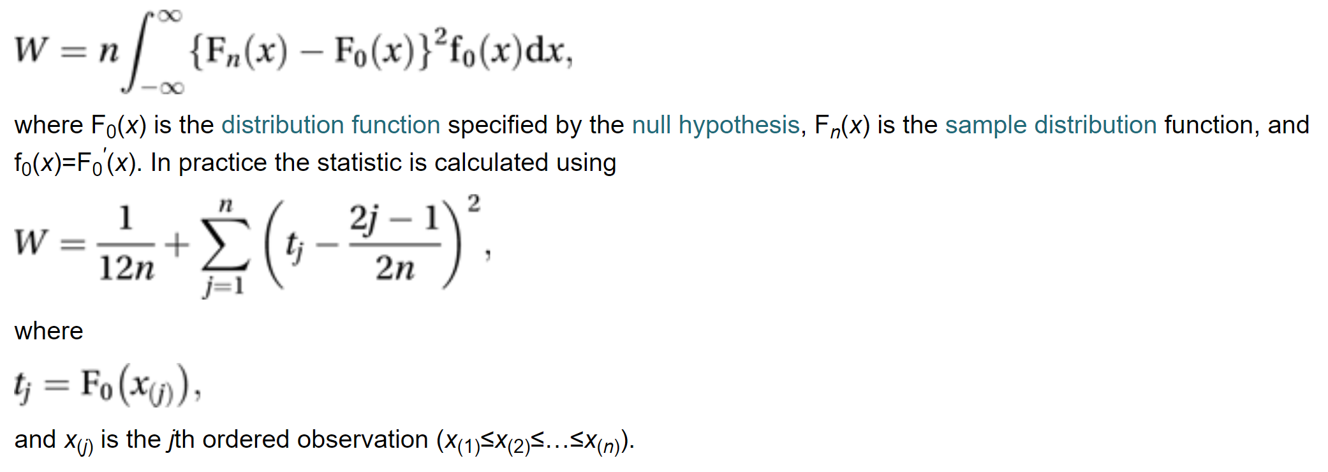

There are extra factors of **n** (no. of observations) and **f(x)** – the predicted pdf in the integral

My CVM & KS implementations are fixed in the Wk7 folder (**error_ks.py, error_cvm.py, error_ks_2samples.py**)

I also implemented 2 new metrics:

* **error_abs.py:** integrates absolute difference between CDFs
* **error_square.py:** integrates squared difference between CDFs (what I though was CVM before)

# Maps

**AAF:**

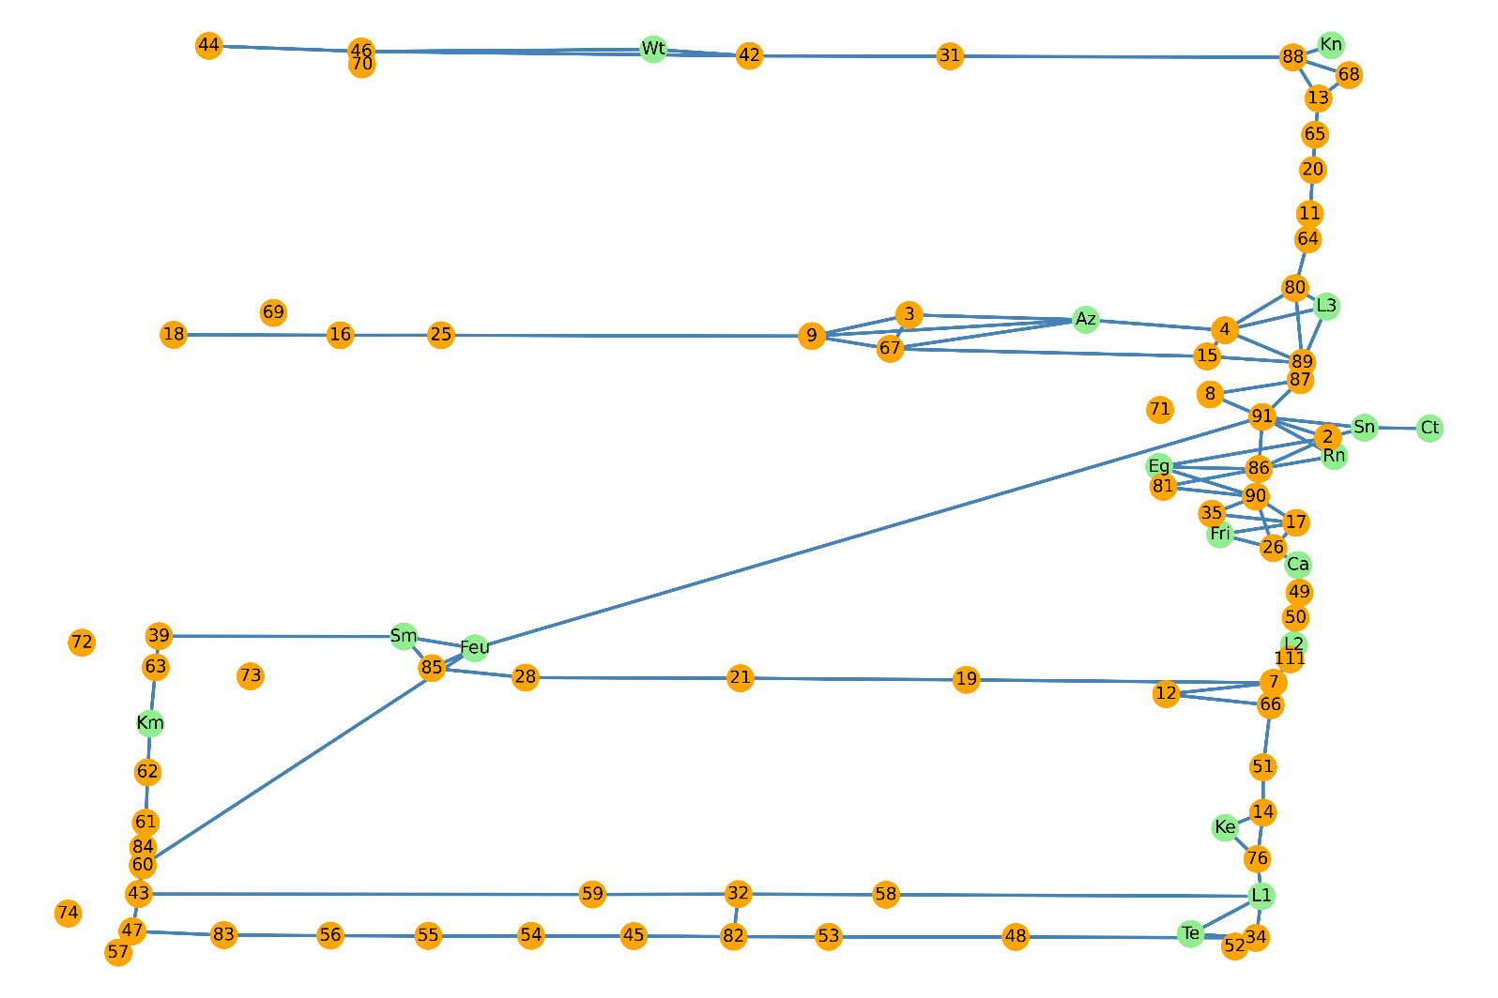

**TSC:**

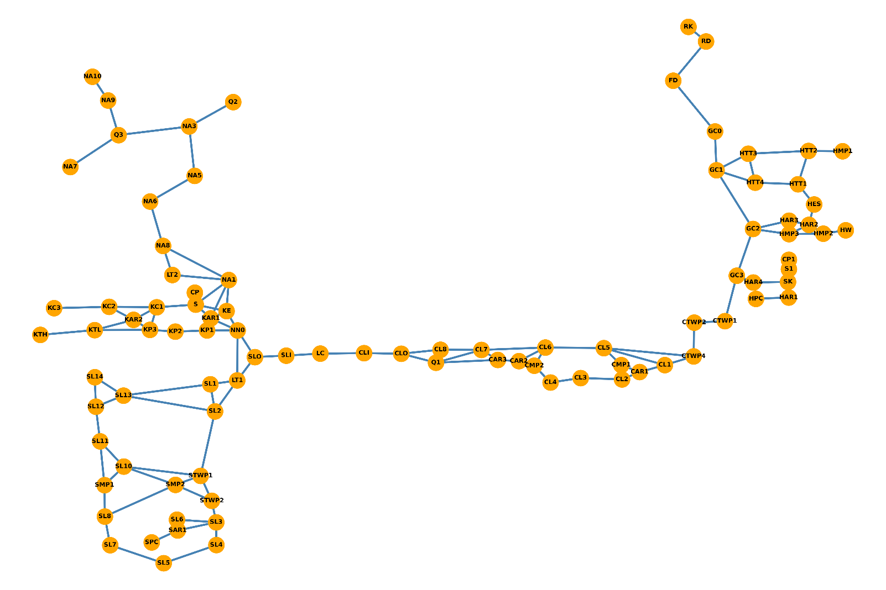

**LABS:**

